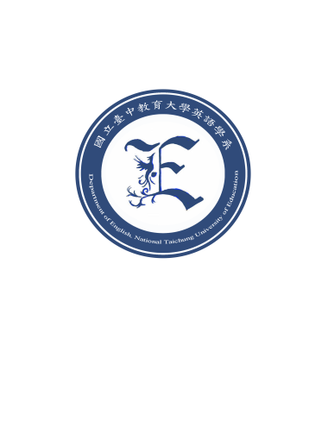
Master’s Program of the English Department
2026.06.27
Updated
National Taichung University of Education

Supporting Evidence for Academic Research Experiences and Achievements

Note: Please complete the form using 12-point Times New Roman. Delete or add spaces as needed.

- Participation in On-campus or Off-campus Academic Research Projects: If the project was carried out by the applicant, please attach proof of project approval. If the applicant served as a research project assistant, please attach a letter of recommendation from the principal investigator.

- Publicly Published Academic Papers: For each published paper, please provide an abstract of no more than 500 words.

- Course Reports / Term Papers: For each report or paper, please provide an abstract of no more than 500 words.

