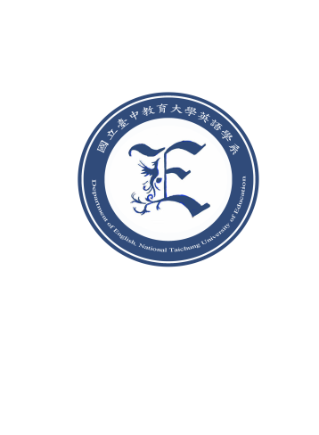
2025 Master’s Program in English
請依實際需求增減內容，以12號Time News Roman編寫
National Taichung University of Education

Statement of Interest
A statement of interest is a description of your research interests. The statement is generally in the form of a short essay (approximately three pages). Please include:
- Your research topic: Your specific areas of academic interests and the research topic you want to work on;
- Your background: How your past experiences have prepared you to pursue your interests;
- Related literature: Refer to academic publications that have informed your interests;
- Your study/career goals: What you hope to achieve in the graduate program; state why this particular program at NTCU is the best place for you to pursue your interests.

